Storage Lifecycle Policies
What Is a Storage Lifecycle Policy?
In Snowflake, a Storage Lifecycle Policy is a special rule you create that automatically manages old or unnecessary data in your tables. Instead of manually deleting or archiving data, Snowflake will do it for you every day.
It’s like setting a cleanup rule on your storage that says:
- “Move data older than 90 days to cheaper storage,” or
- “Delete rows older than 365 days.”
This helps reduce storage costs, ensures compliance, and keeps your data manageable.
How It works
1. Create a policy with a condition (like age of data).
2. Attach the policy to a table.
3. Snowflake waits ~24 hours then runs the policy daily.
4. When it runs:
- It archives matching data to cooler (cheaper) storage, or
- It expires/deletes rows permanently.
Must know Thingns :
The policy runs daily but starts about 24 hours after attaching.
You can only attach one storage lifecycle policy per table.
When the policy runs, it may lock updates/deletes on that table temporarily.
Benefits :
1. Reduce Cost Storage Moves old or infrequently used data to lower-cost tiers.
2. Compilance Automatically deletes data based on retention policies.
3. Automation Daily execution without manual scripts.
Archive Tiers :
COOL Fast retrieval; must keep at least 90 days.
COLD Much cheaper, slower retrieval (can take hours); must keep 180+ days.
BILLING :
The storage lifecycle policy saves long-term storage costs by archiving or expiring data, but it doesn’t make the process free. We pay for the compute it uses, the storage it moves to, retrieving data if needed, and any minimum billing time imposed by the cloud provider.
1. Policy Execution Cost (Compute)
Every time Snowflake runs your storage lifecycle policy (about once a day):
- It uses serverless
- compute to look through your table,
- Check which rows match your policy conditions,
- And then archive/expire those rows.
Each run consumes compute credits, so you pay for that compute usage.
2. Archive Storage Costs
Once rows are archived (moved to COOL or COLD storage):
✔ You pay storage costs for that archived data (just like normal data).
✔ The exact rate depends on the storage tier and cloud provider pricing.
Important: even though Snowflake moves the data immediately, the data still remains in your active table storage for a short period due to Time Travel + Fail-safe before Snowflake stops charging for those active copies.
3. Data Movement (Compute) to Archive Storage
When matched rows are actually moved into the COOL or COLD tier:
- Snowflake charges a one-time compute cost for that data movement — it’s not free.
That means every time rows transition from normal table storage into archive storage, you pay a small compute fee for that action.
4. Data Retrieval Costs
If later you want to retrieve archived rows (e.g., via CREATE TABLE ... FROM ARCHIVE OF):
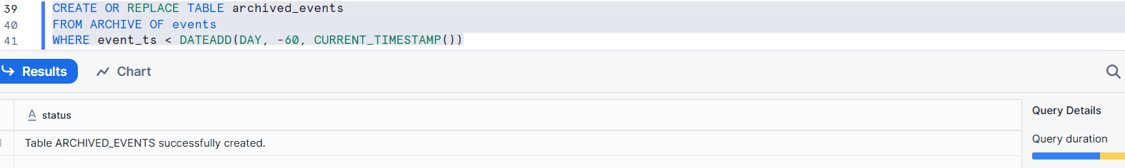
You can be charged:
- A one-time retrieval cost for pulling data from the archive tier.
- A compute cost to process/read that data.
- If the data was in COLD tier, retrieving temporarily places it in normal storage, which also incurs storage charges while it remains there.
Archive Tier | Minimum Duration
COOL | 90 days
COLD | 180 days
5. Minimum Storage Duration Charges (Cloud Provider Rules)
Cloud storage providers like AWS require minimum storage time in archive tiers:

If you drop a table before that period ends, Snowflake still bills you for the remaining minimum period — because the cloud provider won’t refund early deletion.
So it’s not that the policy itself is paid separately — it’s that compute + storage usage triggered by the policy creates cost just like any other Snowflake action.
CREATE AND MANAGE STORAGE LIFECYCLE POLICIES :
STORAGE LIFECYCLE POLICIES :
A Storage Lifecycle Policy is a schema object that automatically identifies rows to archive or expire (permanently delete) based on conditions you define (e.g., age of data).
After attaching the policy to a table, Snowflake automatically runs it once every 24 hours using system compute.
FOR DEMO :
STEP 1: Create a Demo Table
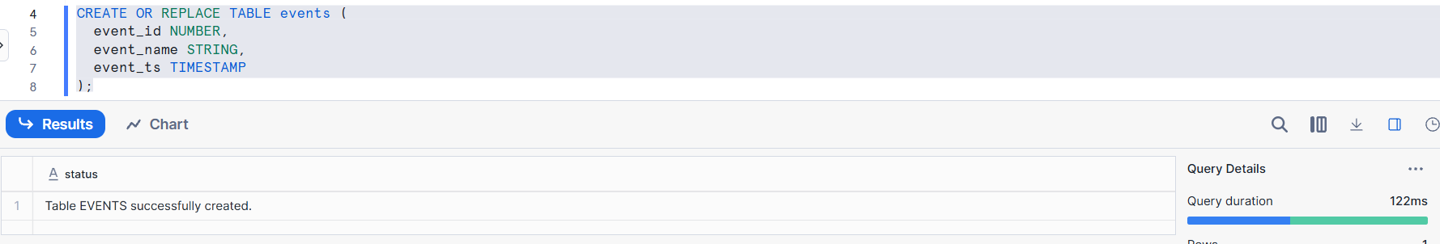
This table stores event data
event_ts will be used to decide which data is old
STEP 2:
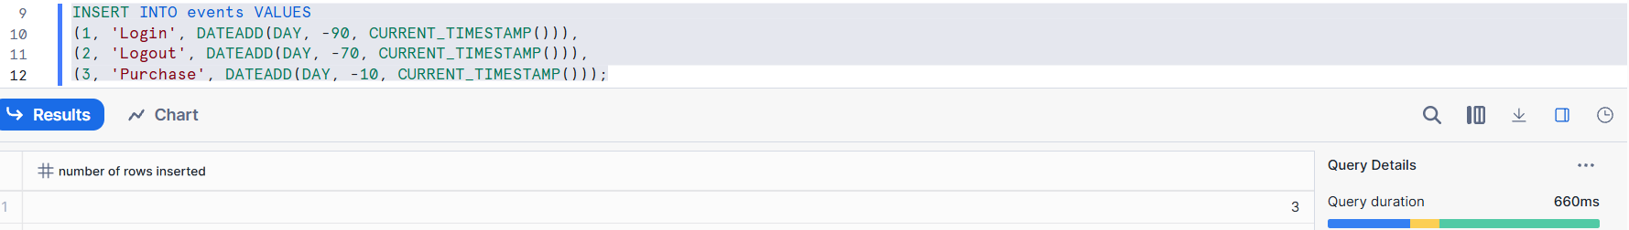
Some rows are older than 60 days
Some rows are recent
Policy will target only old rows
select * from events;
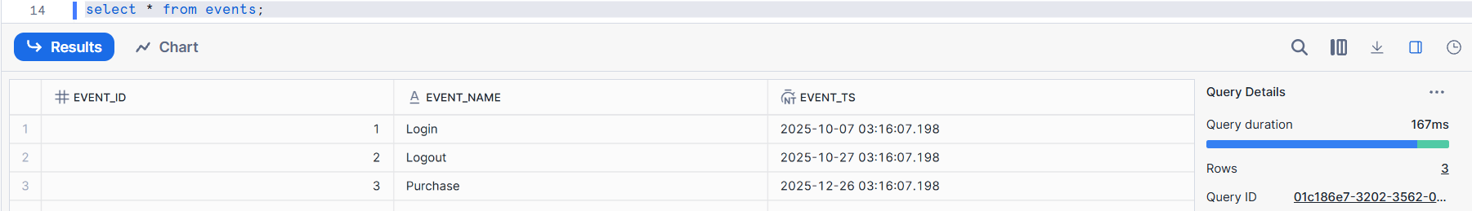
Step 3: Create Storage Lifecycle Policy
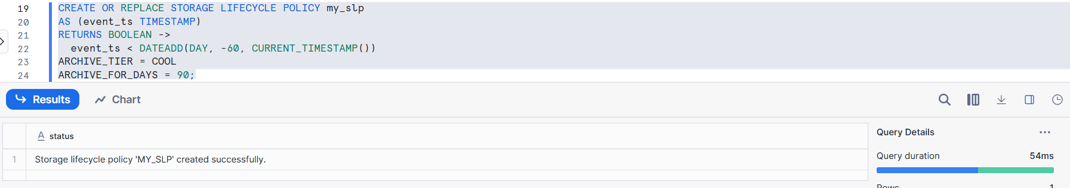
Policy logic is defined inside the policy
Rows older than 60 days will be archived
Archived data goes to COOL storage
Data stays there for 90 days before deletion
Step 4: Attach Policy to Table 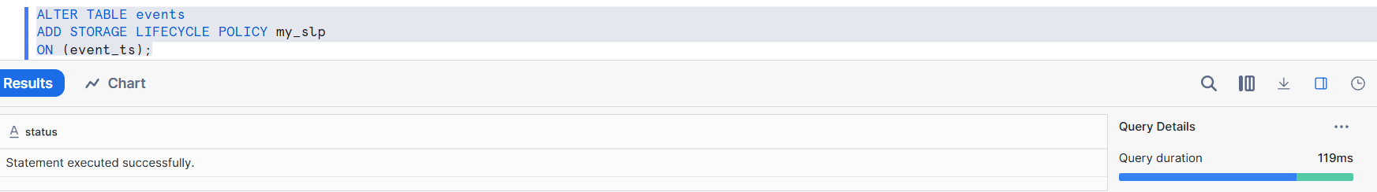
Policy is now linked to the table
Column binding happens here
Only one lifecycle policy per table
Step 5: Explain Execution Timing
The policy does not run immediately.
Snowflake evaluates lifecycle policies once per day, and the first run usually happens within 24 hours.
Step 6 : Monitor Policy Execution
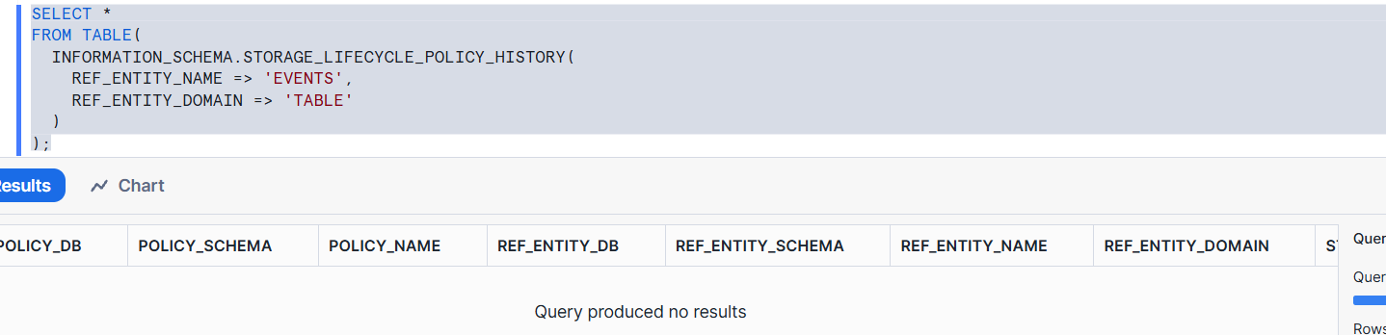
This shows when the lifecycle policy ran and how many rows were archived.
Because,the query is not yet started .
If the policy runs once, the output is like this:
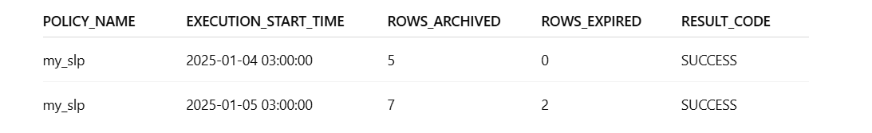
Step 7 : Show Archived Data Retrieval

This creates a new table archived_events containing all archived rows matching your WHERE filter.
You can then query this table normally:
select * from archived_events;
Step 8 : Remove Policy
ALTER TABLE events
DROP STORAGE LIFECYCLE POLICY;
For Confirmation :
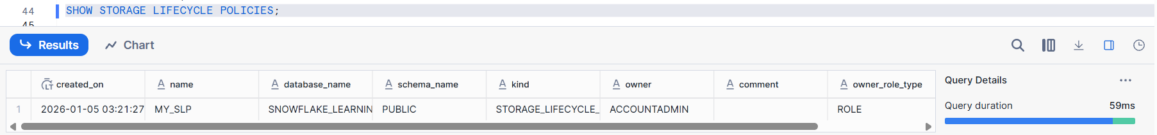
RETRIEVE ARCHIVED DATA :
When Snowflake archives rows because of a storage lifecycle policy, those rows:
✔ Are no longer in the active table
✔ Are stored in archival storage (COOL or COLD)
✔ Can’t be queried directly anymore
✔ Must be restored before you can see or use them
The policy has not yet run long enough to move data to archive. We must wait for at least one daily run, and only then can we restore archived rows.
Archived data must be restored using CREATE TABLE … FROM ARCHIVE OF with a WHERE clause, and it only works once the lifecycle policy has actually archived rows.
MONITORING:
Once you create and attach a storage lifecycle policy to a table, you want to track what happened, when it ran, and what it did.
This monitoring view shows execution history only after the lifecycle policy runs, which happens once per day. If no rows appear, it means the policy has not executed yet.
Monitoring Provides :
History of how the policy ran
When the policy executed
How many rows were archived/expired
Results of each run
This helps you verify the policy is working correctly.
For Monitoring:
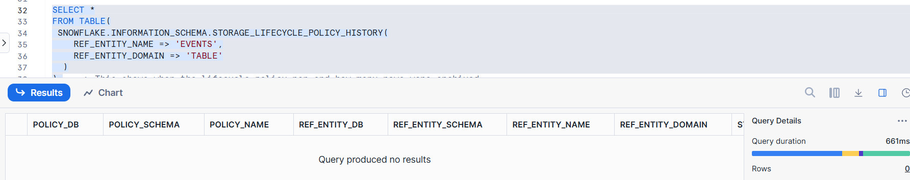
Show “Query produced no results” (which is expected if policy hasn’t run yet)
If the policy runs once, the output is like this:


